ANGLEŠČINA: REŠITVE UČNEGA LISTA – RAZRED: 8. r, 3. nivo – skupina Zajc Kalar, Kavšek 7. TEDNA dela od doma: 5. do 8. maj 2020
!!! Na voljo je tudi koda za uporabo spletnega učbenika English Plus z vsemi posnetki – glej prilogo 4. tedna!!
INFORMACIJE GLEDE PREJŠNJEGA TEDNA:
- Kdor ni rešil spletnega preverjanja znanja, lahko to še stori in pošlje rezultate svoji učiteljici (glej navodila za 7. teden). Kviz je na voljo v spletni učilnici.
PRVA URA: TOREK, 5. 5. 2020 – Feelings (Unit 8) (75. ura)
1. Uvod – Poveži pravilno izraze v spodnji razpredelnici. Prepiši jih v svoj zvezek, v zadnji koloni pravilne pare.
phobia | exciting and a bit scary events | PARI so v posameznih barvah!
thrills | a possibility
caving | irrational fear of something
an option | not sure
risky | the act of exploring underground world

2. Osrednji del ure
Naloga 2 (slušni tekst 2. 22):
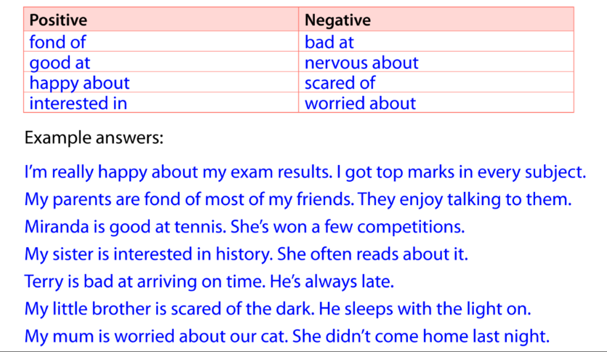

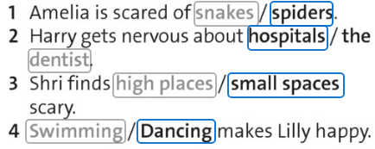
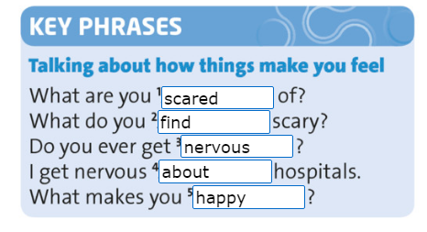
Naloga 4 (slušni tekst 2. 23) in KEY PHRASES:

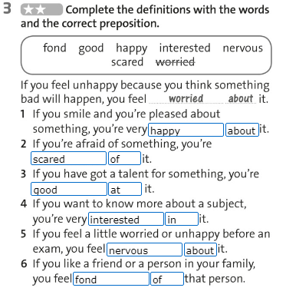
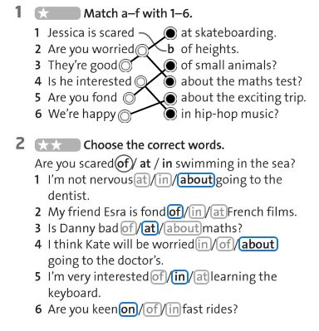
3. Zaključek – Naloge v DZ na strani 64 od 1 do 5
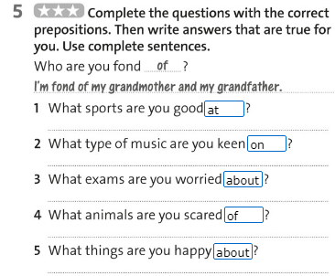
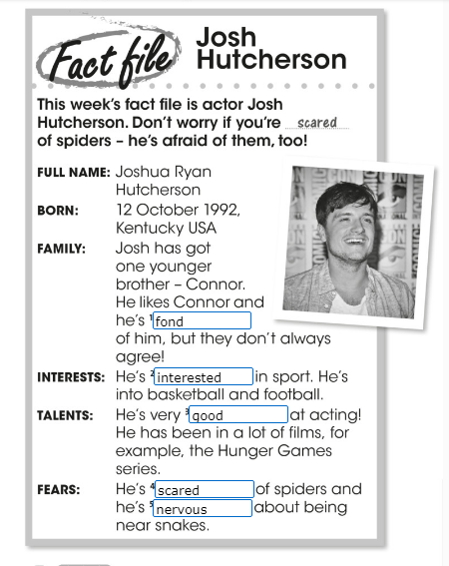

Današnja zanimivost: Poslušaj posnetek o strahovih na povezavi. Pod posnetkom sta nalogi razumevanja in besedišča.
to faint - to lose consciousness – omedleti, izgubiti zavest
to freak someone out (informal) - to make someone feel extremely angry, excited or worried – spraviti nekoga ob živce
sinister - threatening, or that seems bad or evil – resen, tudi slab, zloben
flight - escaping or running away - pobeg
to pose a threat - to be potentially dangerous – groziti, grozeč
to giggle - to laugh repeatedly in a quiet and uncontrollable way – hihitati se
to trigger something - to cause something to start – sprožiti nekaj, začeti
traumatic - causing great emotional shock and upset – travmatično, pretresljivo

DRUGA naloga:

The difference between common fears and phobias - Extract 1
A fear of heights - Extract 3
Symptoms of phobias - Extract 1
Why we like to be scared - Extract 2
A memory of fainting at the doctors-Extract 3
A fear one person has suffered their whole life - Extract 3
The fight or flight response - Extract 2
Why people develop phobias - Extract 1
The importance of context and danger - Extract 2

https://learnenglishteens.britishcouncil.org/skills/listening/advanced-c1-listening/fear-factor

DRUGA URA: ČETRTEK, 7. 5. 2020 – Scream machines (76. ura)
1. Uvod – REŠITVE spletnih nalog:

https://www.learnenglishfeelgood.com/adjectives-prepositions1.html#

1. I'm not capable of that type of behavior.
2. Smoking is bad for you.
3. I'm so angry about this!
4. I'm so angry with you!
5. She was dressed in pink.
6. This restaurant is famous for its mussels.
7. George is married to a German woman.
8. Are you afraid of him?
9. I'm so proud of you!
10. We're not associated with that company.

https://www.ecenglish.com/learnenglish/lessons/adjective-preposition-challenge
1 - I'm not enthusiastic about fishing, but I'll come anyway.
2 - We were all pleased with our exam results.
3 - Malta is famous for its great weather.
4 - Although we look the same, she's not related to me.
5 - We've become very attached to this house. We don't want to move.
6 - He looks mean, but he's capable of great generosity.
7 - Can you recommend a book that's suitable for her.
8 - Tom is hopeless at remembering birthdays.
9 - Her dress is very similar to mine.
10 - The steets were crowded with people.

https://test-english.com/grammar-points/b1/adjective-preposition/
1. We are super excited about the trip.
He's famous for his science experiments on YouTube.
He is totally different from his brother.
You are very bad at lying.
He isn't capable of taking care of himself.
He's obsessed with his new toy.
We're very proud of you.
How long have you been married to Liam?
I'm fed up with my new boss. I hate him.
I'm not very keen on having to wear a uniform, but I need the job.

https://www.usingenglish.com/quizzes/results.php
1 - She's been married to her husband for twenty years.
2 - He's married with two kids.
3 - It is similar to mine.
4 - He's interested in music.
5 - She was responsible for the mess.
6 - That's typical of them.
7 - I am sick of their behaviour.
8 - They're capable of passing.
9 - I'm a bit short of cash; could you lend me some?
10 - I wasn't aware of what had happened.
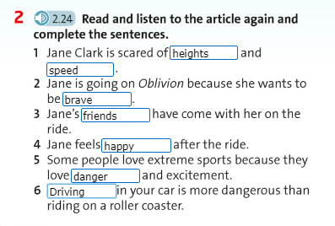
2. Osrednji del ure
Naloga 2 (2. 24), učbenik stran 80:

TRETJA URA: PETEK, 8. 5. 2020 – Present Perfect Simple (77. ura)

2. Osrednji del ure
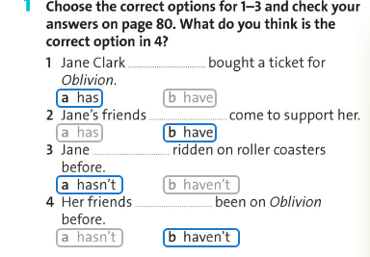
Naloga 1 na strani 81 v učbeniku
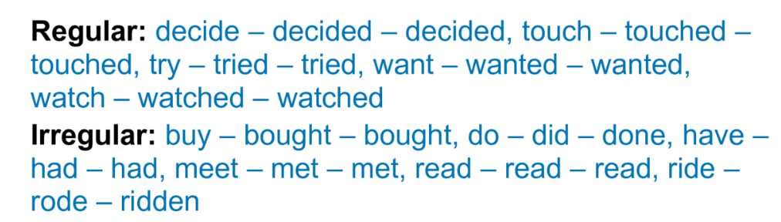
b) Naloga 3 na isti strani

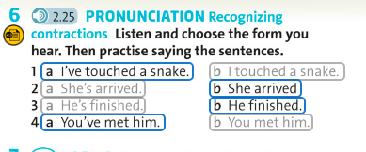
Naloga 6:

3. Zaključek ure
Rešitve spletnih nalog:
https://agendaweb.org/exercises/verbs/present-perfect = PREVERI rešitve sam ob nalogi
http://www.focus.olsztyn.pl/en-present-perfect-tense-exercises-with-answers.html#.Xp6G8cgzbIU

1. They have left London this month. (leave)
2. He has brought a lot of English papers. (bring)
3. She has told me about it. (tell)
4. I have got a long letter from father this week. (get)
5. She (just) has just come; she will speak to you in a minute. (come)
6. I have been to Radio City. (be)
7. I think the director has left the town. (leave)
8. I have painted my office. (paint)
9. We have known her since she arrived to our city. (know)
10. I have forgotten your name. (forget)
11. He has closed the door. (close)
12. He has done it since we left him. (do)
13. I have given him my last penny. (give)
14. This order has led to many misunderstandings. (lead)
15. He has written his name on my book. (write)
16. She has bought a new umbrella. (buy)
17. He has looked my exercise over and over. (look)
18. I have bought those books very cheaply. (buy)
19. He has worked for two months. (work)
20. She has found a new job. (find)
21. He has spoken very well. (speak)
22. The children have eaten the whole pudding. (eat)
23. You have read many detective stories. (read)
24. Our team has won the first prize. (win)
25. My little daughter has cut her finger with a knife. (cut)

https://www.englishclub.com/grammar/verb-tenses_present-perfect_quiz.htm
1. has
2. Have
3. 've
4. Have
5. have
6. forgotten
7. Has
8. have found
9. for
10. since
https://www.examenglish.com/grammar/A2_present_perfect.htm - PREVERI REŠITVE SAM ob nalogi

